Protocols For Improving Lipids, Inflammation, & HA1C

The following cholesterol managing guidelines provide the dietary steps for managing inflammation and HA1C as well. Inflammation and glucose are primarily issues of an excess energy intake, too many carbs. Additionally, bad fats, a high Omega 6:3 ratio, and processed foods negatively impact lipids, CRP, and glucose levels. Therefore, a whole, natural food ketogenic diet or modified Mediterranean diet is the pathway to heart health along with supplementing additional Omega 3.
The choice between Keto or Mediterranean is based on both DNA and the blood lipid results.

Types Of Cholesterol:
High-density lipoproteins (HDL), or “HDL cholesterol.”
Commonly known as the “good” cholesterol, many of these lipoproteins transport cholesterol to the liver rather than to artery walls. As a scavenger of excess cholesterol from lipoproteins and tissues, these can actually prevent heart disease.

What is not commonly known:
There are multiple types of HDLs. The smaller more mature ones are not as healthy as the larger versions. https://www.ncbi.nlm.nih.gov/pmc/articles/PMC4593254/ (for those that want to read more)

Important to read before presenting:
https://www.endocrineweb.com/news/heart-disease/60978-hdl-doesnt-protect-all-women-against-heart-disease

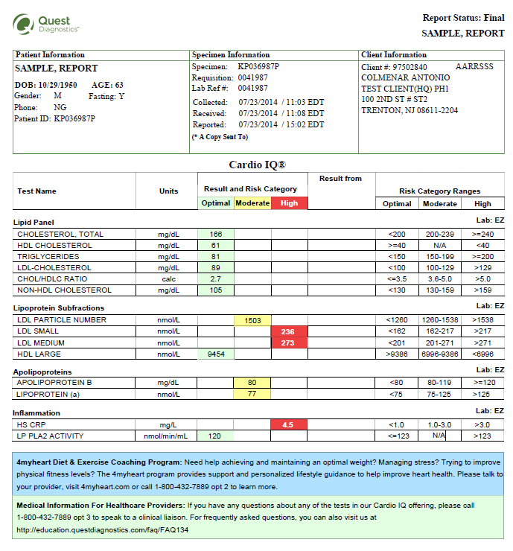

Low-density lipoproteins (LDL), or “LDL cholesterol.”
Commonly known as the “bad” cholesterol. These carry cholesterol from the liver to cells—as well as to the arteries that require it. New findings show us that there are different types of LDL particles. Understanding the difference can be very important in reading your cholesterol panel:
- VLDL or “very low-density lipoprotein,” which carries triglycerides and is a precursor to LDL particles.
- LDL-A are large and fluffy, and generally regarded as harmless.
- LDL-B are smaller, harder, and denser, and can promote atherosclerosis.

While the idea was once that you get more fat and cholesterol in the blood and tissues from eating fat and cholesterol, the science has come to show this is not the case.
Actually, it’s more likely that too many carbs will cause the excess sugar to be converted to fat by the liver. This is actually how you produce the more dangerous cholesterol and lipid profile that causes cardiovascular disease.
After the sugar is converted to fat in the liver, the body then kicks out triglyceride carrying chylomicron and triglycerides. High triglycerides are major risk factor for death.
Additionally, these triglycerides get packed into the VLDLs. VLDLs are the upstream precursor to immature, small, dangerous atherosclerotic LDL particles.

RAISING HDL
A positive health goal is to raise HDL. Many things impact cholesterol levels, including diet, fitness levels, and genetics. Although several genes are associated with our HDL cholesterol level, genetics has a moderate overall impact on this when you consider all the other lifestyle factors.

The following are steps proven effective to raising good, HDL cholesterol.
- Reducing carbs to a more anti-inflammatory, ketogenic or a Modified Mediterranean diet.¹ (Modified calls for a reduction grains and starches)

Weight loss will generally create an increase in HDL levels.
- A focus of the Mediterranean diet is Extra virgin olive oil; also found to raise HDLs. An evaluation of multiple studies involving over 800,000 subjects discovered that olive oil was the best monounsaturated fat to reduce heart disease. ² Olive oil contains antioxidants known as polyphenols believed to provide heart benefits and create the increase in HDL.³
- Use coconut oil. A randomized, double-blind, clinical trial involved 40 women aged 20-40 years found that it lowered HDL while other studies also revealed that it improves the LDL to HDL ratio important in preventing heart disease.⁴
- Research has always shown how important exercise is for cardiovascular health. Additionally, studies point to the fact that resistance training, HIIT (High-intensity interval training) and aerobic exercise all raise HDL.

Stop smoking! One way that smoking increases heart disease risk is through lowering HDL.
- Up your Omega-3 fatty acids. Eating healthy types of fish or taking fish oil can help to elevate HDL levels, decrease inflammation, and improve cardiovascular function.
- Eliminate trans fats. Rancid fats from vegetable, nut, and see oils along with added trans fats or hydrogenated oil negatively affect cholesterol ratios, cause inflammation, and promote heart disease.
- Eat foods rich in anthocyanins such as blueberries, blackberries, eggplant, and red cabbage.

LDL
Cholesterol is an essential component of cell membranes within the body. It is made up of low-density lipoprotein (LDL or "bad" cholesterol) and high-density lipoprotein (HDL or "good" cholesterol). Diet is a source of cholesterol, but the body also makes it. A high LDL cholesterol levels can cause a risk for heart disease and other health issues, especially if your HDL cholesterol level is low. Several factors contribute to overall cholesterol levels including both lifestyle and genetics.
Many things impact cholesterol levels, including diet, lifestyle, and genetics. Although several genes are associated with our LDL cholesterol level, genetics has a moderate overall impact on this when you consider all the other factors.
Diet can affect cholesterol levels, including our LDL cholesterol level. An excess of carbohydrates raises LDL particle counts and decreases particle size; both are key issues related to risk factors for CVD. Therefore, carb reductions is incredibly valuable in managing unhealthy LDL types and levels.
Saturated fats, like those in full-fat dairy products or red meat, can increase LDL cholesterol levels and negatively influence LDL particle count; particularly for those with certain genotypes such as APOE and FTO. Some studies show that whey protein supplements can lower total cholesterol levels, including LDL cholesterol.

MORE IMPORTANT THAN TOTAL LDL

Early, limited research related to cardiovascular disease appears to have pushed doctors to focus on total LDL levels as the critical biomarker when assessing disease risks.¹ Yet, mounting evidence shows that while it has a role in atherosclerosis, it has limited value as a biomarker of health or prevention of disease. Other key markers required to truly assess risk status include but are not limited to: measuring inflammatory (hsCRP), Triglyceride:HDL ratio, total cholesterol:HDL ratio, and Fatty Acid status.

DIET AND LOWERING LDL
The foods recommended for improved LDL levels point in the direction of the modified Mediterranean diet.
Choose foods that are higher in monounsaturated fat and fiber and lower in sodium, sugar, saturated fat, vegetable oil, and trans-fat.² Trans-fats have the double negative of decreasing HDL while increasing LDL.
Helpful foods to manage LDL include fish, Omega 3 plant foods such as flax and chia seeds, lean poultry, raw nuts and seeds, low-glycemic fruits, and plenty of green vegetables for their soluble fiber.³
Eating foods that are higher in fiber, like oatmeal, beans, eggplant, okra, raw nuts and seeds, and soluble fiber from Brussels sprouts and low-glycemic fruits such as blueberries, blackberries, raspberries, and green-apples can help lower LDL and boost HDL cholesterol.⁴⁻⁵
Fitness, weight loss, and smoking also play vital roles in healthy LDL levels and the overall risk of cholesterol and CVD.
TRIGLYCERIDES
Another problem with all of the excess sugar energy (Too many carbs) in the diet is that it can lead to excess triglycerides and create the bad kind of cholesterol. While this is generally blamed on fats, it’s really more bad news about carbs.
In reality, getting fat is a metabolic marker of too much carb energy and the growing inability of your body to manage all the sugar and the excess fat it creates. Since the intake of more sugar than your body can manage causes obesity, obesity related diseases, high triglycerides, bad cholesterol, and advanced aging we say, “Carbs Kill.”
Bread, pasta, rice, breakfast cereal, and 1000s of snacks like crackers and pretzels are often labeled “fat-free, cholesterol-free, sugar-free.” This is of course a marketing tactic to get the unsuspecting public buy a food because it appears to be good for you.
While the truth is, they really don’t contain any fats, triglycerides, or cholesterol and some don’t even contain sugar, they’re far from “free.”
The waist expanding problem is, these “fat, sugar, and cholesterol free” carbs stimulate insulin, which causes fat production. These fats then end up in a flow of triglycerides that must be packed into cholesterol to be carried in the blood.
In other words, these “free” carbs ultimately lead to fat, triglycerides, and bad cholesterol.
The advice to “eat carbohydrates to avoid fat” doesn’t account for the fact that eating carbohydrates is essentially eating fat – and lots of it. It’s not what you eat—it’s what your body makes of it.
Cholesterol and triglyceride free carbs create the dangerous, small LDL particles; the “LDL pattern B” that are dangerous to your heart. They also lead to high triglycerides. ⁽¹⁻⁶⁾

LOWERING TRIGLYCERIDES
The great news is, when starting a low carb diet, which doesn’t include these “free-foods,” people will normally lower triglycerides and steadily raise HDL very quickly.⁽⁷⁻⁹⁾ The key with triglycerides is carb control through either a ketogenic diet or modified Mediterranean.¹⁰ Additionally, omega-3 fatty acids from fish helps lower triglyceride levels.

References

HDL
- https://www.ncbi.nlm.nih.gov/pubmed/17447017
- https://www.ncbi.nlm.nih.gov/pubmed/25274026
- https://www.ncbi.nlm.nih.gov/pubmed/26011257
- https://www.ncbi.nlm.nih.gov/pubmed/19437058

LDL
- https://www.biospace.com/article/ldl-cholesterol-does-not-predict-heart-risk-among-heart-patients/
- https://www.sciencedirect.com/science/article/pii/B9780123849472000490
- https://www.ncbi.nlm.nih.gov/pubmed/26762372
- https://www.ncbi.nlm.nih.gov/pubmed/24710915
- https://www.ncbi.nlm.nih.gov/pubmed/22190137

Other References:

- Effect of high-carbohydrate feeding on triglyceride and saturated fatty acid synthesis. LC, Hudgins. 2000, Proc Soc Exp Biol Med, pp. 178-83.
- Variations in oxidative susceptibility among six low density lipoprotein subfractions of differing density and particle size. al., Tribble DL et. 1992, Atherosclerosis, pp. 189-99.
- 3. Susceptibility of small, dense, low-density lipoproteins to oxidative modification in subjects with the atherogenic lipoprotein phenotype, pattern B. al., Chait A et. 1993, Am J Med, pp. 350-6.
- Carbohdrate restriction has a more favorable impact on the metabolic syndrome than a low fat diet. Volek, J.S., et al. 2009, Lipids.
- Dietary and genetic probes of atherogenic dyslipidemia. Krauss, R.M. 2005, Arteriscler Thromb Vasc Bio.
- Low-density lipoprotein subclass patterns and lipoprotein response to a reduced-fat diet in men. Dreon, D.M., et al. 1994, Faseb J.
- Weight loss with a low-carbohydrate, Mediterranean, or low fat diet. Shai, I. et al. 2008, N Engl J Med, pp. 229-41.
- The lipid triad in type 2 diabetes—prevalence and relevance of hypertriglyceridaemia/low high-density lipoprotein syndrome in type 2 diabetes. Temelkova-Kurktschiev T, Hanefeld M. 2004, Exp Clin Endocrinol Diabetes, pp. 75-9.
- Carbohydrate-induced hypertriacylglycerolemia: Hisotrical perspective and review of biological mechanisms. Parks EJ, Hellerstein MK. 2000, Am J Clin Nutr, pp. 412-23.
- Dashti HM, et al. Long term effects of ketogenic diet in obese subjects with high cholesterol level. Mol Cell Biochem. June 2006.

